Coplanar Points
# Source: AI Source: Provided by: [Data Path: Persons Table -> ID Column: 1, Name_En Column: Motasem Essam] -> From: [ChatGPT] on [7/25/2026]
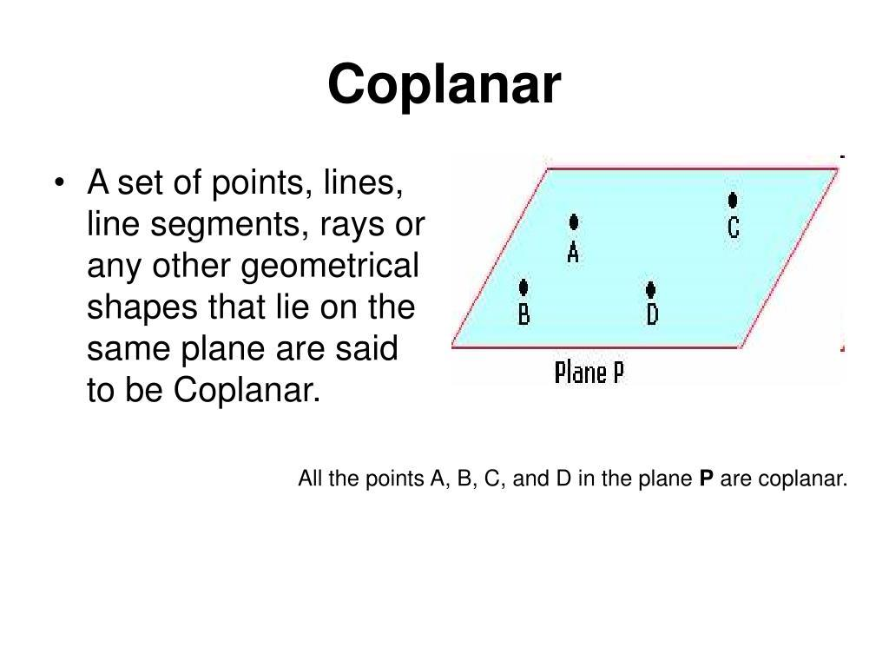
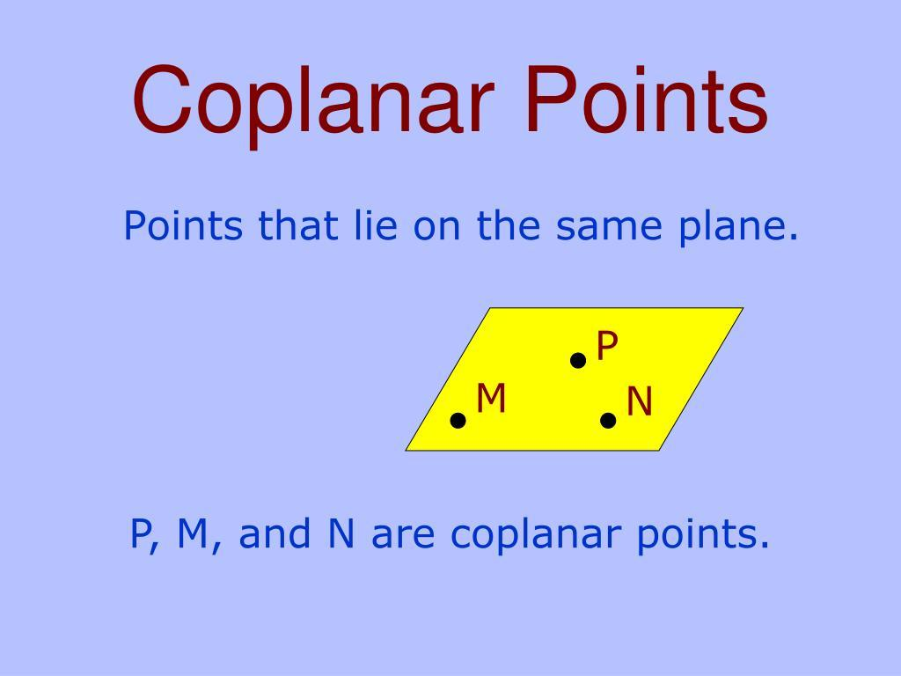
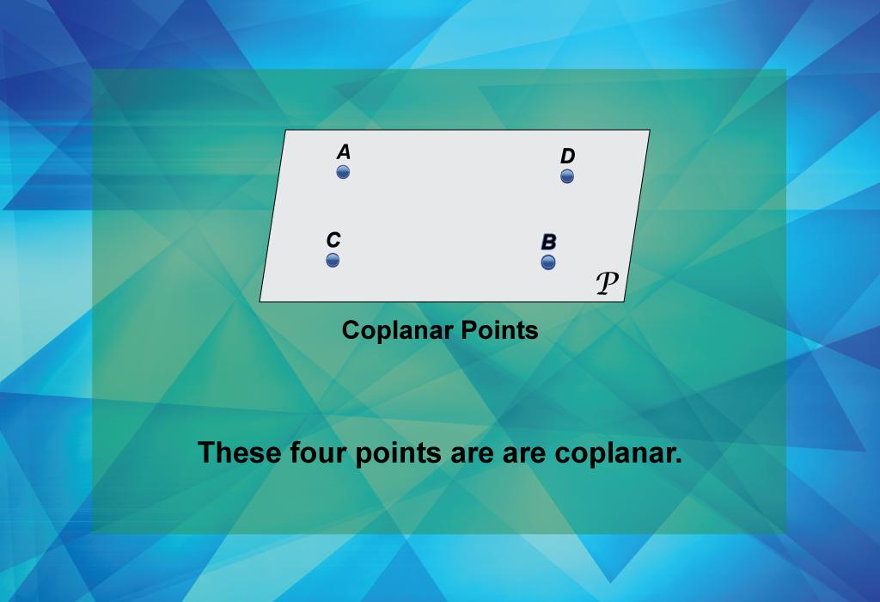
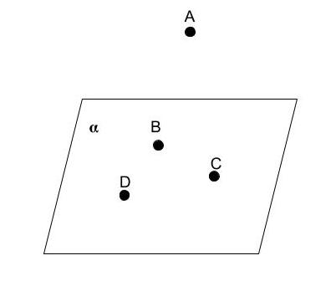
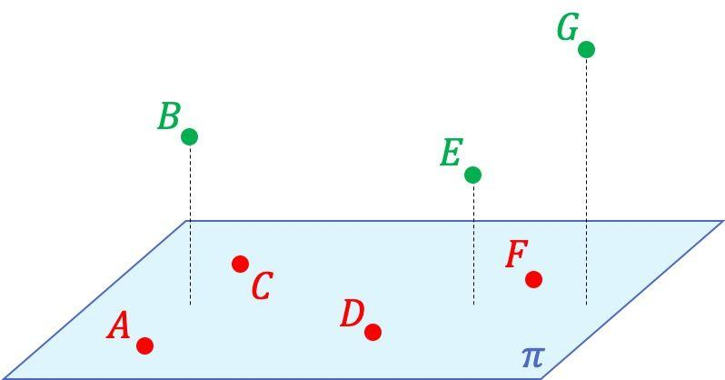
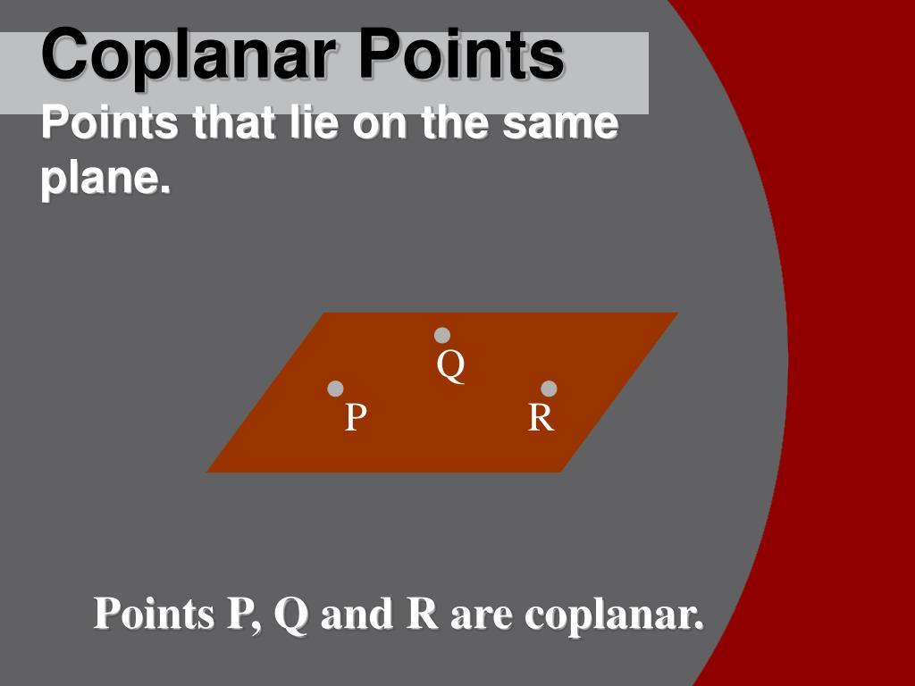

Definition
# Source: AI Source: Provided by: [Data Path: Persons Table -> ID Column: 1, Name_En Column: Motasem Essam] -> From: [ChatGPT] on [7/25/2026]
Coplanar Points are two or more points that lie on the same plane. A plane is a flat, two-dimensional surface that extends infinitely in all directions.
If all the points can be contained within a single plane, they are said to be coplanar.

Characteristics
# Source: AI Source: Provided by: [Data Path: Persons Table -> ID Column: 1, Name_En Column: Motasem Essam] -> From: [ChatGPT] on [7/25/2026]
Coplanar points:
- Lie on the same plane.
- Share a common flat surface.
- May be collinear or non-collinear.
- Can form two-dimensional geometric figures such as triangles, quadrilaterals, and polygons.
- Are commonly used in plane geometry and three-dimensional geometry.

Illustration
# Source: AI Source: Provided by: [Data Path: Persons Table -> ID Column: 1, Name_En Column: Motasem Essam] -> From: [ChatGPT] on [7/25/2026]

Plane

• A • B

• C

• D
Points A, B, C, and D all lie on the same plane, so they are coplanar.

Examples
# Source: AI Source: Provided by: [Data Path: Persons Table -> ID Column: 1, Name_En Column: Motasem Essam] -> From: [ChatGPT] on [7/25/2026]
Three Coplanar Points

A •────────• B

•

C
The three points lie on the same plane.

Four Coplanar Points

A •────────• B

C •────────• D
All four points lie on one plane.

Mathematical Description
# Source: AI Source: Provided by: [Data Path: Persons Table -> ID Column: 1, Name_En Column: Motasem Essam] -> From: [ChatGPT] on [7/25/2026]
Points
$$A, B, C, D$$
are coplanar if there exists a plane that contains all of them.
In coordinate geometry, any three non-collinear points determine a unique plane. A fourth point is coplanar if it also lies on that same plane.

Properties
# Source: AI Source: Provided by: [Data Path: Persons Table -> ID Column: 1, Name_En Column: Motasem Essam] -> From: [ChatGPT] on [7/25/2026]
Coplanar points:
- Belong to one plane.
- May be collinear or non-collinear.
- Can define plane figures.
- Three non-collinear coplanar points determine a unique plane.
- Any number of points may be coplanar if they all lie in the same plane.

Applications
# Source: AI Source: Provided by: [Data Path: Persons Table -> ID Column: 1, Name_En Column: Motasem Essam] -> From: [ChatGPT] on [7/25/2026]
Coplanar points are used in:
- Plane Geometry
- Solid Geometry
- Coordinate Geometry
- Engineering
- Architecture
- CAD (Computer-Aided Design)
- Computer Graphics
- GIS (Geographic Information Systems)
- Robotics
- Structural Design

Advantages
# Source: AI Source: Provided by: [Data Path: Persons Table -> ID Column: 1, Name_En Column: Motasem Essam] -> From: [ChatGPT] on [7/25/2026]
Studying coplanar points helps to:
- Describe flat geometric arrangements.
- Construct geometric figures.
- Analyze spatial relationships.
- Support engineering and architectural drawings.
- Simplify geometric proofs.

Limitations
# Source: AI Source: Provided by: [Data Path: Persons Table -> ID Column: 1, Name_En Column: Motasem Essam] -> From: [ChatGPT] on [7/25/2026]
Coplanar points:
- Are limited to a single plane.
- Cannot represent spatial arrangements involving multiple planes.
- Require three-dimensional analysis when points are not coplanar.

Comparison with Non-Coplanar Points
# Source: AI Source: Provided by: [Data Path: Persons Table -> ID Column: 1, Name_En Column: Motasem Essam] -> From: [ChatGPT] on [7/25/2026]

Type | Description
Coplanar Points | Lie on the same plane
Non-Coplanar Points | Do not all lie on the same plane

Key Points
# Source: AI Source: Provided by: [Data Path: Persons Table -> ID Column: 1, Name_En Column: Motasem Essam] -> From: [ChatGPT] on [7/25/2026]
- Coplanar Points lie on the same plane.
- They may be:
  - Collinear
  - Non-collinear
- Three non-collinear coplanar points determine a unique plane.
- Coplanar points are fundamental in geometry, engineering, architecture, CAD, GIS, and computer graphics.

Conclusion
# Source: AI Source: Provided by: [Data Path: Persons Table -> ID Column: 1, Name_En Column: Motasem Essam] -> From: [ChatGPT] on [7/25/2026]
Coplanar Points are points that lie within the same plane, sharing a common two-dimensional surface. They form the basis for constructing and analyzing plane figures such as triangles, quadrilaterals, and polygons. Coplanarity is a fundamental concept in plane geometry, solid geometry, coordinate geometry, engineering, architecture, CAD, GIS, robotics, and computer graphics, where understanding whether points lie on the same plane is essential for accurate geometric modeling and spatial analysis.

